**Understanding the Launch Results**

This article was updated to support v4.1 of Goliath Application Availability Monitor.

With the Goliath Application Availability Monitor (GAAM), the launches run on a scheduled basis behind the scenes and generate log output. The purpose of this document is review log output provided in the Goliath Application Availability Monitor Analysis page and Reports.

**GAAM Stages**

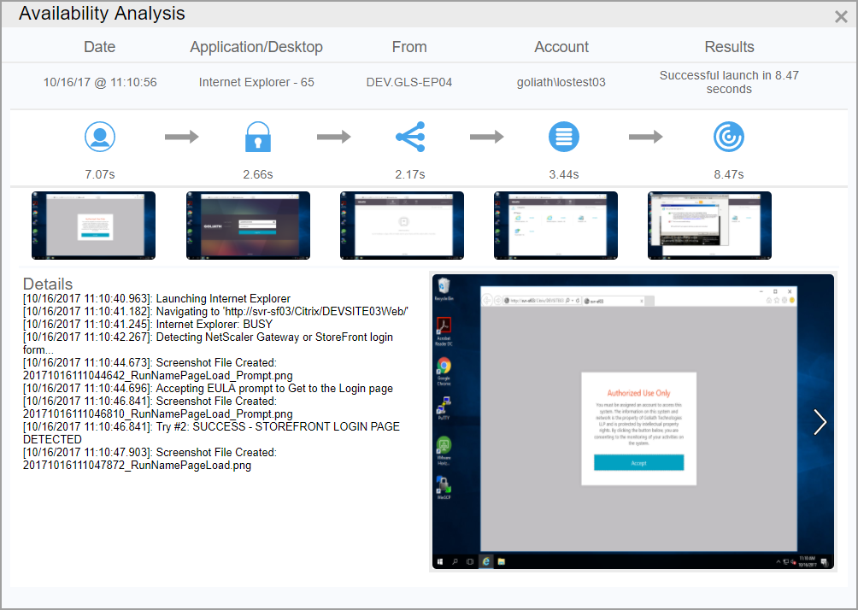

|  |  |  |
| --- | --- | --- |
| **Stage Icon** | **Stage Name** | **Stage Description** |
| blobid0.png | Access | Browser launch to site load |
| blobid1.png | Authentication | Entering the credentials and clicking the ‘login’ button |
| blobid2.png | Resources | Confirming the page which holds the apps/desktops is loaded |
| blobid3.png | Enumeration | Searching for the apps/desktops |
| blobid4.png | Launch | App/Desktop click to load |

**General Log Terms**

* **Navigating to 'https://wesbite’**
  + The web address that GAAM is connecting to
* **Try # _: Waiting…**
  + This message pertains to the configured ‘launch timeout’, which is the threshold of how much time in seconds GAAM will search during a phase. The ‘Try #’ will display which second it is on, ‘waiting...’ indicates that the GAAM has not yet found what is it looking for.
* **Try # _: SUCCESS**
  + This message pertains to the configured ‘launch timeout’, which is the threshold of how much time in seconds the GAAM will search during a phase. The ‘Try #’ will display which second it is on, ‘SUCCESS’ indicates that the GAAM has validated this stage and it will move onto the next
* **Screenshot File Created:**
  + This message pertains to the screenshot feature of the technology.
* **Screenshot Cannot be Taken - Console Session is not available**
  + This message pertains to the screenshot feature of the technology. An active console session to the endpoint is required in order for a screenshot to be captured.
* **Setting UserName / Setting Password**
  + Entering the user credentials
* **Clicking login button**
  + Clicking the login button to initiate login
* **Start LOS Launch Processing for Resource='____' and Title='____'; User Name: '____'**
  + This message indicates that the GAAM is starting the application/desktop search and launch phase.
* **Getting Tab/Folder '_____'...**
  + This message indicates that the GAAM is going to start searching for the Tab or Folder where the application is located
* **Searching for Tab/Folder: ______**
  + This message indicates that the GAAM is searching for the Tab or Folder where the application is located. It will report back all of the items it is finding along the way.
* **Click Tab/Folder '_____' to Get Resources**
  + This message indicates that the GAAM found the Tab or Folder where the application is located.
* **Searching for Resource: _____**
  + This message indicates that the GAAM is starting to search for the application/desktop
* **Resource '_____' not found**
  + This message indicates that the GAAM was unable to find the application/desktop on the Storefront page.
* **Clicking resource '_______'**
  + This message indicates that the GAAM found the application/desktop on the Storefront page and is going to launch it.
* **Verifying that session launched for Resource='_____' and Title='_____'**
  + This message indicates that the GAAM is starting to search for the application, based on the defined window title, to confirm that is successfully launched. If no window title is defined, the validation will be to look for any new Citrix process.
* **Found session Matching '_____'**
  + This message indicates that the GAAM was successfully able to identify the application/desktop launch.
* **Match process with PID=__  and Title='___ ' to Resource=' ____' and Title='____’ for User='___'**
  + When the GAAM is successfully able to identify an application/desktop launch, it will display the process ID, full window title, name of the app/desktop, window title defined by the user, and the user.
* **Try # _: No match on window title='_____'**
  + This message indicates that the GAAM is searching for the application/desktop and during the process if found a new Citrix process that didn’t match the window title defined.
* **WARNING: Unable to confirm that session launched for Resource='___' and Title='___'**
  + This message is displayed when the GAAM is unable to find the application/desktop
* **Verify-Launch result for ____ is _____**
  + This message indicated whether the launch for a given application/desktop was successful or not. (True/False)
* **End LOS Launch Processing for Resource='____' and Title='____'; User Name: '____'**
  + This message indicates that the GAAM launch phase for a given application/desktop has ended. If more than one application/desktop is defined in a given simulation it will then move onto the next one.
* **Delay 60 seconds to allow all launched windows to Open**
  + Once all of the application/desktop launches are complete, by default the GAAM will pause for 60 seconds before starting the logoff process.
* **Sleeping __ seconds before logging off...**
  + In addition to the default 60 seconds, the GAAM can be configured to stay open an additional amount of time.
* **Getting log off link...**
  + This message indicates that the GAAM is looking for the logoff link for the storefront page.
* **Log off link not found, closing Internet Explorer**
  + This message indicates that the GAAM was unable to find the logoff link for the storefront page, therefore it will proceed to the next steps of closing Internet Explorer.
* **Clicking log off link**
  + This message indicates that the GAAM found the logoff link for the storefront page and is clicking it to logoff the user.
* **Quitting Internet Explorer**
  + This message indicates that the GAAM is exiting Internet Explorer.

**GAAM for Citrix Log Terms**

* **Detecting NetScaler Gateway or StoreFront Login form…**
  + This message indicates that the GAAM is starting the phase of looking for the NetScaler Gateway/Storefront/Web interface login page.
* **STOREFRONT LOGIN PAGE DETECTED**
  + This message indicates that the GAAM is identified that it has successfully reached the Storefront login page.
* **NETSCALER GATEWAY DETECTED**
  + This message indicates that the GAAM is identified that it has successfully reached the NetScaler login page.
* **Detected Resource Page; Skipping Login Page**
  + This message indicates that the GAAM was searching for the login page, but discovered that is was on the page that holds all of the app & desktops. Therefore, it will skip trying to sign into the site and proceed to the next stage.
* **Click 'Continue' button to Get to Login page**
  + If there is a EULA prompt configured to prompt before or after Storefront/NetScaler login, the GAAM can be configured to accept these prompts. This message indicates that there was a EULA prompt and it was clicked, the GAAM will proceed to the next stage.
* **Getting SF resources page...**
  + This message indicates that the GAAM is starting the phase of confirming that the page with the applications and desktops displayed is reached.
* **SF resources page not found**
  + This message indicates that the GAAM was unable to confirm that it reached the page with the applications and desktops displayed within the allotted time.
* **Found Desktop Window for '_____'**
  + This message indicates that the GAAM found the Desktop Window for a VDI or published desktop.
* **Searching for Any Error Windows**
  + By default, the GAAM will search for any client-side Citrix Receiver errors. This message indicated that the search is starting.
* **Error Window text: '____'**
  + By default, the GAAM will search for any client-side Citrix Receiver errors. This message indicates that an error was found and it will also display the error text.
* **Clicking 'OK' to Close Error Window**
  + By default, the GAAM will search for any client-side Citrix Receiver errors. This message indicates that the error window was closed and the GAAM will not proceed further.
* **Clicking to retry launch of resource '_____'**
  + If the GAAM fails to identify an application/desktop launch, it can be configured to click the application/desktop again

**GAAM for Cerner Patient Portal Log Terms**

* **Detecting Patient Portal login form...**
  + This message indicates that the GAAM is confirming that the login page has been reached
* **PATIENT PORTAL DETECTED**
  + This message indicates that the GAAM has identified that it has successfully reached the Patient Portal login page.
* **AUTHENTICATION PAGE NOT FOUND**
  + This message indicates that after navigating to the website the patient portal login page was not reached within the specified time frame
* **Confirming the web page loaded...**
  + After entering the user credentials, GAAM will confirm whether or not the user’s portal page was reached
* **Confirming the username loaded...**
  + This message indicates that the GAAM is searching to confirm the full user name was loaded in the portal
* **Confirming the allergies pane loaded...**
  + This message indicates that the GAAM is searching to confirm the allergies list was loaded.